PRE ACTIVITY:

* Explain briefly what your learnings so far on the Twitter Visualization activities done in the class about social media data visualization.
  + In the Twitter Visualization activity we learned how to use Python to parse a CSV file, filled with data from the Twitter API, and display graphs using plotly, numpy and pandas.
* Give your thoughts on programming in Python based on the activities performed. Do you prefer this over Java? If yes then support your point with a reason.
  + We do not have a preference. Which language you use really depends on the context. For something like this we would rather use python because of how flexible the language is.
* List down the tasks/graphs you want to show on the dashboard
  + Show the number of fake accounts in comparison to number of total accounts or number of non-fake accounts.
  + Show buzz words involved the most in tweets that have negative feedback on twitter.

USE CASES:

**Nuisance Tweet detection**

**Author (s): _TheDashBros_ Date: _11/13/2019_**

**Version: __1.0____**

|  |  |  |  |
| --- | --- | --- | --- |
| **USE CASE NAME:** | **Nuisance Tweet detection** | | **USE CASE TYPE** |
| **USE CASE ID:** | 001 | | **Business Requirements: þ** |
| **PRIORITY:** | Medium | |  |
| **SOURCE:** | N/A | |  |
| **PRIMARY BUSINESS ACTOR:** | Twitter | | |
| **OTHER PARTICIPATING ACTORS:** | Companies that advertise on Twitter. | | |
| **OTHER INTERESTED STAKEHOLDERS:** | Celebrity Twitter Users | | |
| **DESCRIPTION:** | This system will detect the tweets that cause the most negative disruption on twitter, so we can analyze that data to prevent further tweet disruption. It will do this by finding tweets that have high views, comments, and possibly retweets, but low likes. It will then search the tweet and comments for negative keywords to indicate it is causing a disruption on twitter. | | |
| **PRE-CONDITION:** | None | | |
| **TRIGGER:** | System action will be triggered on the command of this twitter team. | | |
| **TYPICAL COURSE** | **Actor Action** | **System Response** | |
| **OF EVENTS:** | **Step 1**:We tell the system to detect nuisance tweets. | **Step 2**:System finds tweets with the highest comments, retweets, and view but low likes. | |
|  |  | Step 3: System will sort through these tweets, only looking for tweets with negative connotation words in the tweet or comments. | |
|  |  | Step 4: System will retrieve and group these tweets and store them in a viewable file. | |
|  | Step 5: We will be able to view this file to use for our graphs and dashboards. |  | |
| **ALTERNATE COURSES:** | Step 5: We will not sort through and remove any tweets that caused a negative disruption, but are not a nuisance to twitter (ex: a bad movie trailer, or the U.S. President’s tweets). | | |
| **CONCLUSION:** | This system will make it possible for us to analyze what common tweet trends cause distribution on twitter so we can prevent further disruption in the future. | | |
| **POST-CONDITION:** | N/A | | |
| **BUSINESS RULES** | ·N/A | | |
| **IMPLEMENTATION CONTRAINTS AND SPECIFICATIONS** | The system must only view and retrieve information from twitter, but not edit, block or remove and tweets or twitter users from using twitter. | | |
| **ASSUMPTIONS:** | This is assuming that the biggest tweet problems on twitter are not being liked by a majority of the users that view the tweet. | | |
| **OPEN ISSUES:** | It is possible that tweets that do not cause a disruption can be grouped into this file by the system, but this will be resolved when the team views the information. | | |
|  |  |  |  |

**Fake Account Detection**

**Author (s): _TheDastBros__ Date: _11/13/2019_**

**Version: ___1.0____**

|  |  |  |  |
| --- | --- | --- | --- |
| **USE CASE NAME:** | **Fake Account Detection** | | **USE CASE TYPE** |
| **USE CASE ID:** | 002 | | **Business Requirements: þ** |
| **PRIORITY:** | Medium | |  |
| **SOURCE:** | N/A | |  |
| **PRIMARY BUSINESS ACTOR:** | Twitter | | |
| **OTHER PARTICIPATING ACTORS:** | Companies that advertise on Twitter. · | | |
| **OTHER INTERESTED STAKEHOLDERS:** | Celebrities Twitter Users.· | | |
| **DESCRIPTION:** | This system will go through accounts on Twitter, and detect the fake account that seem to cause disruption, by either spam posting, sending untrusted links to other users, or posing anything not allowed on Twitter (such as ISIS propaganda which has been a problem for all social media). Once detected, the system will store the account information of all the fake accounts in a viewable file for the team. | | |
| **PRE-CONDITION:** | N/A | | |
| **TRIGGER:** | This team will trigger the system to analyze and detect the fake accounts. | | |
| **TYPICAL COURSE** | **Actor Action** | **System Response** | |
| **OF EVENTS:** | **Step 1**: The team will tell the system to detect and retrieve information from the fake accounts. | **Step 2**: The system will find accounts with names that seem randomly generated, accounts that keep contacting other users unsolicited at a rapid rate, and accounts that show other common signs of being a fake account. | |
|  |  | Step 3: The system will collect all this information, group it, and store it in a file for the team to use. | |
|  | Step 4: The team will retrieve this information and create graphs for the dashboard with it. |  | |
| **ALTERNATE COURSES:** | N/A | | |
| **CONCLUSION:** | This system will help the team to build the dashboard to clean up Twitter and remove any fake account that causes problems for other users. | | |
| **POST-CONDITION:** | N/A | | |
| **BUSINESS RULES** | This system must not automatically delete any account deemed fake by this system, because the account might not actually be fake and that a violation of the user on Twitter’s behalf. | | |
| **IMPLEMENTATION CONTRAINTS AND SPECIFICATIONS** | The system must only view and retrieve information from twitter, but not edit, block or remove and tweets or twitter users from using twitter. | | |
| **ASSUMPTIONS:** | This system will assume that current fake accounts on Twitter are following the same format and trends that past fake accounts have followed. | | |
| **OPEN ISSUES:** | N/A | | |
|  |  |  |  |

**Nuisance Tweet detection**

**Author (s): TheDashBros Date: 11/13/2019**

**Version: 1.0**

|  |  |  |  |
| --- | --- | --- | --- |
| **USE CASE NAME:** | **Nuisance Tweet detection** | | **USE CASE TYPE** |
| **USE CASE ID:** | 001 | | **o** |
| **PRIORITY:** | Medium | | System Analysis: **þ** |
| **SOURCE:** | N/A | |  |
| **PRIMARY BUSINESS ACTOR** | Twitter | | |
| **PRIMARY SYSTEM ACTOR** | Twitter Users’ Profiles, Twitter, This system. | | |
| **OTHER PARTICIPATING ACTORS:** | * N/A | | |
| **OTHER INTERESTED STAKEHOLDERS:** | * Companies that advertise on Twitter. · | | |
| **DESCRIPTION:** | This system will detect the tweets that cause the most negative disruption on twitter, so we can analyze that data to prevent further tweet disruption. It will do this by finding tweets that have high views, comments, and possibly retweets, but low likes. It will then search the tweet and comments for negative keywords to indicate it is causing a disruption on twitter. | | |
| **PRE-CONDITION:** | N/A | | |
| **TRIGGER:** | Triggered by this Twitter Team. | | |
| **TYPICAL COURSE** | **Actor Action** | **System Response** | |
| **OF EVENTS:** | **Step 1**: Twitter team activates system and tells the system to find unusual view/comment to like ratios. | **Step 2**: The system searches through all of twitter, filtering out any tweet that shows normal signs of activity. | |
|  | Step 3: The team then gives the system a list of negative keywords to detect problematic tweets or comments. | Step 4: The system will then read the tweet and comments looking for negative keywords. | |
|  | Step 5: The team will then tell the system to take the most standout negative tweets and put them in a list, displaying all the profile and tweet information. | Step 6: The system will group all of the negative tweets into a file that is usable now by the team. | |
|  | Step 7:The team is now able to take this file and create graphs to be used for the dashboard. |  | |
| **ALTERNATE COURSES:** |  | | |
| **CONCLUSION:** | This system will make it possible for us to analyze what common tweet trends cause distribution on twitter so we can prevent further disruption in the future. This will all be displayed upon creating of the dashboard. | | |
| **POST-CONDITION:** | N/A | | |
| **BUSINESS RULES** | * The system must not store anyone private information such as passwords or backup security answers. | | |
| **IMPLEMENTATION CONTRAINTS AND SPECIFICATIONS** | * The system must only view and retrieve information from twitter, but not edit, block or remove and tweets or twitter users from using twitter. | | |
| **ASSUMPTIONS:** | * This is assuming that the biggest tweet problems on twitter are not being liked by a majority of the users that view the tweet. | | |
| **OPEN ISSUES:** | There could be tweets that the system does not detect, because people chose to ignore the tweet instead of retweeting and commenting on it, so it would fly under the system radar. | | |
|  |  |  |  |

**Fake Account Detection**

**Author (s): _TheDashBros__ Date: 11/13/2019**

**Version: 1.0**

|  |  |  |  |
| --- | --- | --- | --- |
| **USE CASE NAME:** | **Fake Account Detection** | | **USE CASE TYPE** |
| **USE CASE ID:** | 002 | | Business Requirements: **o** |
| **PRIORITY:** | Medium | | System Analysis: **þ** |
| **SOURCE:** | N/A | |  |
| **PRIMARY BUSINESS ACTOR** | Twitter | | |
| **PRIMARY SYSTEM ACTOR** | Detection System, Twitter, Twitter Users’ Profiles. | | |
| **OTHER PARTICIPATING ACTORS:** | * N/A | | |
| **OTHER INTERESTED STAKEHOLDERS:** | * Companies that advertise on Twitter. · | | |
| **DESCRIPTION:** | This system will go through accounts on Twitter, and detect the fake account that seem to cause disruption, by either spam posting, sending untrusted links to other users, or posing anything not allowed on Twitter (such as ISIS propaganda which has been a problem for all social media). Once detected, the system will store the account information of all the fake accounts in a viewable file for the team. | | |
| **PRE-CONDITION:** | N/A | | |
| **TRIGGER:** | This team will trigger the System activation. | | |
| **TYPICAL COURSE** | **Actor Action** | **System Response** | |
| **OF EVENTS:** | **Step 1**: The team will activate the system and give the system previous common trends of fake profiles. | **Step 2**: The system will take that data and sort through current Twitter profiles that share common trends that previous profiles had. | |
|  | Step 3: The team will then give this system common trends that fake profiles tend to do when they cause problems on twitter. | Step 4: The system will then use this information to sort through the found fake profiles and weed out the profiles that do not seems to cause a disruption. | |
|  |  | Step 5: The system will take the remaining profile data and store it in a file for the team to use further. | |
|  | Step 6: The team will take the data from the file and use this to create graphs, charts, and the dashboard. |  | |
| **ALTERNATE COURSES:** | N/A | | |
| **CONCLUSION:** | This system will help the team to build the dashboard to clean up Twitter and remove any fake account that causes problems for other users. | | |
| **POST-CONDITION:** | N/A | | |
| **BUSINESS RULES** | * This system must not automatically delete any account deemed fake by this system, because the account might not actually be fake and that a violation of the user on Twitter’s behalf. | | |
| **IMPLEMENTATION CONTRAINTS AND SPECIFICATIONS** | * The system must only view and retrieve information from twitter, but not edit, block or remove and tweets or twitter users from using twitter. | | |
| **ASSUMPTIONS:** | * This system will assume that current fake accounts on Twitter are following the same format and trends that past fake accounts have followed. | | |
| **OPEN ISSUES:** | Fake profiles that do not show consistent signs of activity will fly under the system’s radar and not be detected by the system. | | |
|  |  |  |  |

USE CASE DIAGRAM:

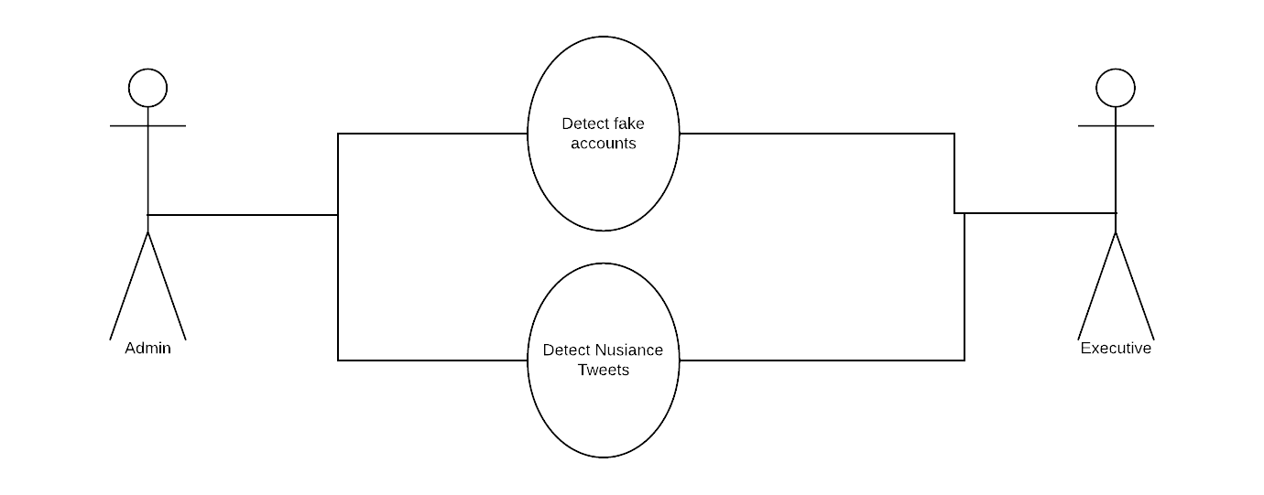

DATA FLOW DIAGRAM:

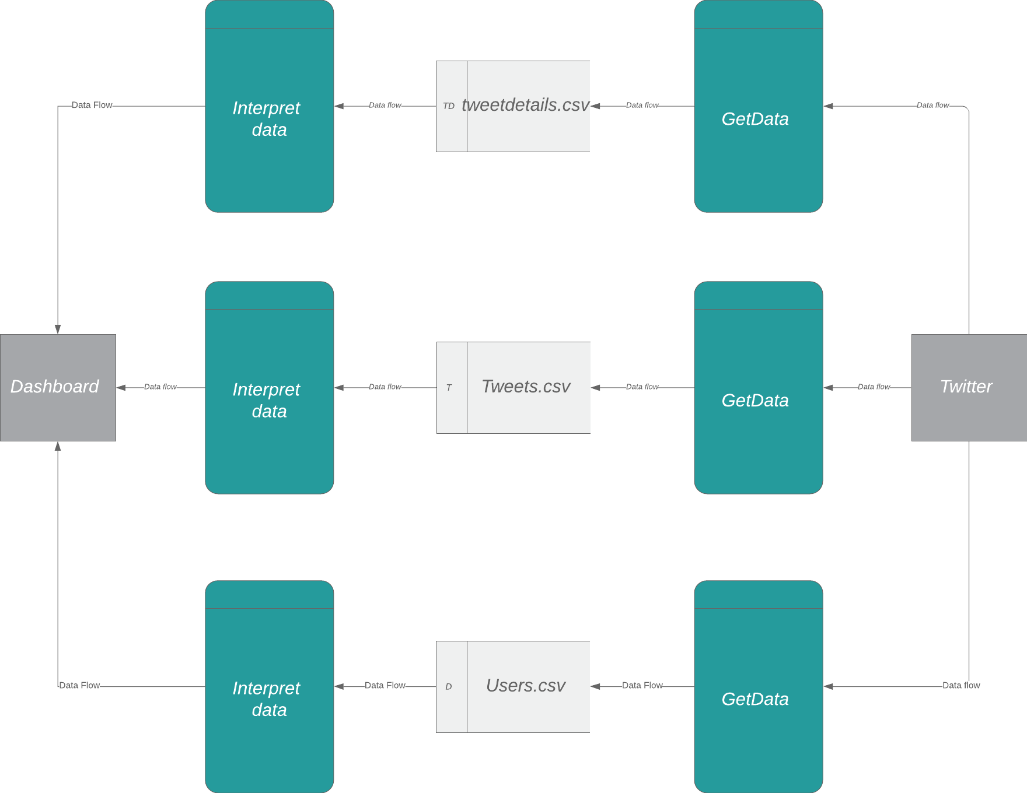

DASHBOARD: 